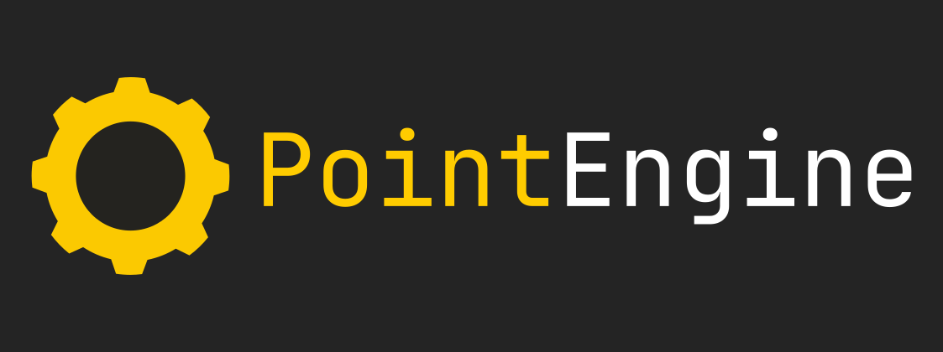
PointEngine Documentation

Getting started

List of contents
Project setup

You need to have cmake to create a game using the PointEngine
You can download it at https://cmake.org/download/ or install it using your package manager of choice.

A Cmake project template is available for download at https://github.com/pointThink/pointengine-game-template

Recursively clone the repository using: “git clone <repo url> --recursive”

The –recursive flag is highly important, since it also gets the submodules from the repository which includes the actual engine source code.

Open the CmakeLists.txt file in the repository and locate the line “set(GAME_NAME template)”. You can set it to whatever you want.

Create a build folder in the repo folder. Open your terminal and go to that folder.

To generate a project/build script use “cmake ..”
This will automatically choose a build system/IDE project for you.
You can manualy set the generator using the -G option followed by the name of the generator

e.g. cmake .. -G”Visual Studio 17 2022”

